26.26: a) If the 12-V battery is removed and then replaced with the opposite polarity,
the current will flow in the clockwise direction, with magnitude;
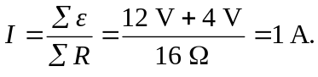
b)

